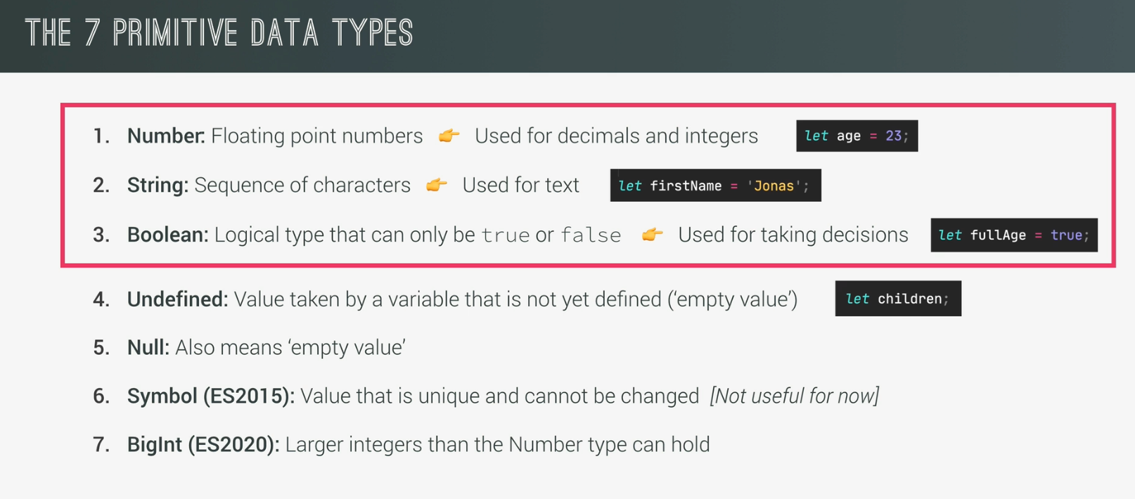



For example,

**var x = 5;**

**x = “hello world”;**

initially x was int, but later we assign string to the variable.

* when we declare a variable without assigning it, in javascript its type and value both will be **undefined.**
* In case of **null**, the value and type will be null as well. But due to a bug in javascript its treated as an object. It’s never corrected due to legacy reasons.
* **NaN** is a special type value of a number type object. When we try to convert a non-number to a number, we get a NaN value. This means Not A Number.